Software Design Document
CPF Group Multi-Subsidiary Analytics Dashboard
Phase 3: Design — Week 7 & 8 Execution Plan
Field | Detail
Designed by | Vincent Onchieku Collins
Document Version | 1.0
Status | Draft — Phase 3 Design deliverable
Template | Data & AI Unit — Software Design Document (SDD) Template v1.0
Governing references | Week 7 & 8 Execution Plan; Phase 1 Scope Note; Phase 2 Analysis; SDLC Document; Core Design Principles; Clean Coding Practices
SDLC alignment: Phase 3, Design (SDLC Document) — this document is the technical blueprint built on the approved Phase 1 and Phase 2 requirements, passed to Development (Phase 5) as its roadmap. It follows the Data & AI Unit's required SDD Template section by section.

1. Introduction
Purpose: to define the design of the CPF Group multi-subsidiary analytics dashboard — a functional draft prototype spanning Rukisha, CPF Financial Services and CPF Capital & Advisory, built for a CPF Group finance manager.
Scope: in scope — three subsidiary views (three service pillars, four KPIs each), a three-layer Group Comparison View (Snapshot, Connection, Combined), and the dashboard shell (horizontal collapsible navigation, individual responsive KPI cards, per-KPI info tooltips, an alerts panel, an About page, and a matching header/footer). Out of scope — real authentication, a live data feed, production security hardening, a native mobile app, and a full automated end-to-end test suite, per the Phase 1 Scope Note.
Definitions and Acronyms: SDLC — Software Development Life Cycle; SDD — Software Design Document; KPI — Key Performance Indicator; AUM/AUA — Assets Under Management/Administration; NAV — Net Asset Value; REIT — Real Estate Investment Trust; CI/CD — Continuous Integration/Continuous Deployment; MoM/QoQ/YTD — Month-on-Month/Quarter-on-Quarter/Year-to-Date; NFR — Non-Functional Requirement.
References: Week 7 & 8 Execution Plan; Phase 1 — Planning (Scope Note); Phase 2 — Analysis (Requirements & Calculation Definitions); SDLC Document; Core Design Principles; Clean Coding Practices; Software Design Document (SDD) Template.

2. System Overview
System Description: a Next.js web application reading a single subsidiary-partitioned Postgres database (Supabase), presenting per-subsidiary and group-comparison views to one user persona — a CPF Group finance manager comparing business lines.
Design Goals: maintainability and clarity; low coupling between each subsidiary's calculation logic; reusable, responsive KPI/chart components; explainability (every KPI's calculation is visible on demand); and a consistent, professional two-tone navy-and-white visual identity built on the CPF Group brand.
Architecture Summary: a modular monolith — one Next.js application, one database — rather than microservices, justified by KISS/YAGNI (Clean Coding Practices §3.2) given the two-week scope and small data volume. Deployed serverless on Vercel.

3. Architectural Design
System Architecture Diagram
flowchart LR
U[Finance Manager] --> UI[Next.js App - Vercel]
UI --> ORCH[Orchestration Layer<br/>Server Actions / API Routes]
ORCH --> DAL[Data Access Layer<br/>Supabase Client Wrapper]
DAL --> DB[(Supabase Postgres)]
SEED[Python + pandas<br/>Seed Scripts] --> DB
Mermaid source — paste into a Mermaid renderer (e.g. the VS Code or GitHub Mermaid preview) to edit.
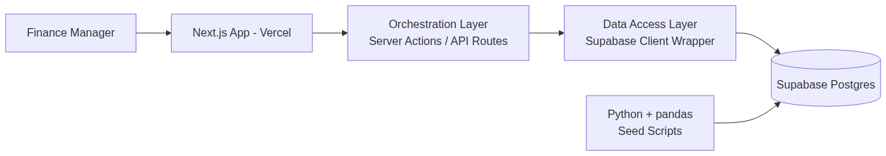
Figure 1 — System Architecture Diagram (rendered).
Module Breakdown
Applying Separation of Concerns and the four-layer split (Core Design Principles §11):
- Entry/Interface layer: pages, the horizontal collapsible navigation bar (subsidiary tabs, Group View, About), the alerts panel, and per-KPI info tooltips.
- Orchestration layer: server actions/API routes sequencing fetch → compute → return.
- Core logic layer: pure calculation functions (no I/O) — one per KPI, as specified in the Phase 2 Analysis document.
- Infrastructure/Data layer: a single Supabase client wrapper (Adapter pattern, Core Design Principles §6–7) isolating all Supabase-specific calls.
Technology Stack
Layer | Technology | Role
Application | Next.js (App Router) + TypeScript | Frontend framework, Vercel-hosted
Data Platform | Postgres via Supabase | System of record, subsidiary-partitioned schema
Data Platform | Python + pandas | Dummy data generation and ETL into Postgres
CI/CD | GitHub Actions | Lint + build check on every push/PR
CI/CD | Vercel | Preview deployments per PR; production auto-deploy on merge to main
Data Flow and Control Flow
sequenceDiagram
actor FM as Finance Manager
participant UI as Dashboard UI
participant ORCH as Orchestration Layer
participant DAL as Data Access Layer
participant DB as Supabase Postgres
FM->>UI: Select subsidiary / tab
UI->>ORCH: Request KPI data (subsidiary, period)
ORCH->>DAL: Fetch rows (filtered by subsidiary_id)
DAL->>DB: SQL query
DB-->>DAL: Rows
DAL-->>ORCH: Typed data
ORCH->>ORCH: Apply core calculation functions
ORCH-->>UI: Computed KPIs
UI-->>FM: Render tiles, charts, alerts
Mermaid source — sequence diagram.
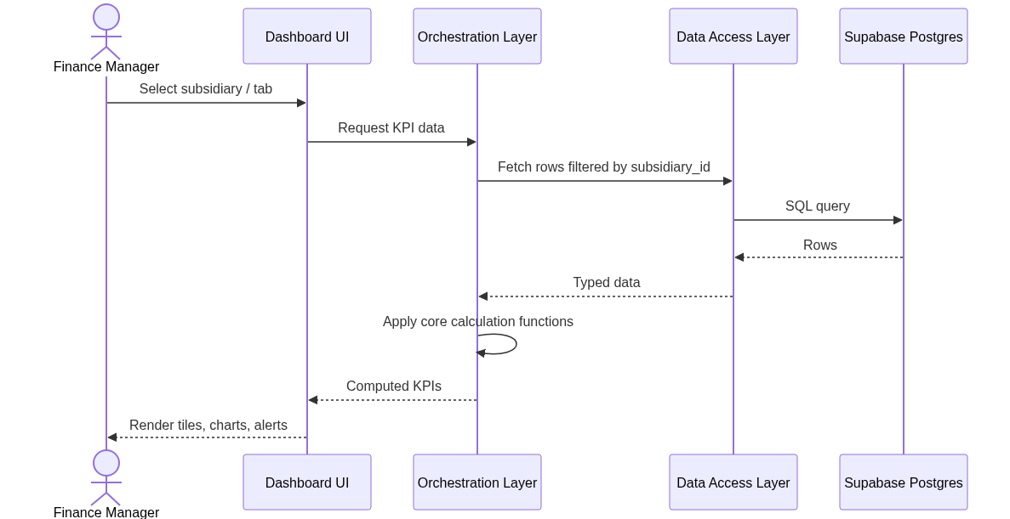
Figure 2 — Data Flow / Control Flow Sequence Diagram (rendered).

4. Detailed Design
This section elaborates the same four modules named in §3's Module Breakdown — Entry/Interface, Orchestration, Core Logic, and Infrastructure/Data — one level deeper. They are not a different set of modules; §3 states what each layer is for architecturally, and this section specifies exactly how each one behaves: its responsibilities, its interface contract (inputs, outputs, error handling), the data it works with, its logic, and how it manages state. The contract for each module is written before implementation, per Core Design Principles §8.

Module: Entry/Interface Layer
- Responsibilities: render the dashboard shell and every visible component — the horizontal collapsible navigation (subsidiary tabs, Group View, About), KPI tile cards with info tooltips, trend/bullet charts, the alerts panel, and the hero toolbar (search, period switch, export). Captures user interaction and hands intent up to the Orchestration layer.
- Interfaces/APIs:
  - Inputs: user interaction events (tab click, period toggle, nav/alerts open-close); computed KPI and alert data received as props from the Orchestration layer.
  - Outputs: rendered UI; the selected tab/period passed back up as a state change.
  - Error Handling: if computed data is missing or empty for a filter, the affected component renders an explicit empty state (“No data for this period”) rather than crashing — the “degrade gently” principle (Core Design Principles, Ten Principles table).
- Data Structures: a KPI view-model {label, value, delta, trend[]}; a NavState {activeTab, navOpen, alertsOpen, period}.
- Algorithms/Logic: none — this layer is presentation-only. Reusable components: SubsidiarySelector, KPICard, InfoTooltip, TrendChart, BulletChart, AlertsPanel, PeriodSwitch, ComparisonView, Footer, AboutPage. A new KPI is added by passing new props to KPICard, never by editing component logic (Open/Closed Principle).
- State Management: local component state only — activeTab, navOpen, alertsOpen, period — no global state library (KISS/YAGNI). State is lifted only as high as the components that need it.

Module: Orchestration Layer
- Responsibilities: sequence each request — call the Infrastructure/Data layer, pass the result to the Core Logic layer's calculation functions, and return the computed result to the Entry/Interface layer. One orchestration function per view (a subsidiary pillar, or a Group Comparison layer).
- Interfaces/APIs:
  - Inputs: selected subsidiary id, selected period (MoM/QoQ/YTD), requested pillar/KPI set.
  - Outputs: a typed object of computed KPI values, deltas and trend series, ready to render directly.
  - Error Handling: wraps Infrastructure/Data layer calls in a try/catch; a raw Supabase error is translated into a generic “data unavailable” state for the UI and logged server-side — the UI never sees a raw database error.
- Data Structures: Request {subsidiaryId, period, pillar}; Response {kpis: KPIResult[]}.
- Algorithms/Logic: a simple sequential pipeline — fetch, then calculate, then shape for the UI. No business logic lives here; calculation itself is delegated to the Core Logic layer (Single Responsibility).
- State Management: stateless — orchestration functions are request-scoped server actions/API route handlers with nothing persisted between calls.

Module: Core Logic Layer
- Responsibilities: hold the pure calculation function for every KPI defined in the Phase 2 Analysis document — all 36 subsidiary KPIs plus the Group Snapshot/Connection/Combined calculations.
- Interfaces/APIs:
  - Inputs: plain data arrays/objects from the Infrastructure/Data layer (e.g. loan rows, contribution rows) — never a database client or network call.
  - Outputs: a single computed value or small structured result per function — a percentage, a currency total, a trend array.
  - Error Handling: each function validates its own inputs (e.g. a zero denominator) and returns a defined “not applicable” result rather than throwing — see the edge cases catalogued in Phase 2 Analysis §1.
- Data Structures: plain typed records matching the Database Design tables (§5) — no ORM entities, no framework-specific types.
- Algorithms/Logic: one pure function per KPI (DRY — calculated once, reused by every tile/chart that needs it), e.g. calculateDefaultRate(loans), calculateFundBalance(contributions, withdrawals, returns), calculateUnitNav(holdings, navHistory), calculateSubscriptionRate(issuance). Full formulas are specified in Phase 2 Analysis §1 and are not repeated here, to keep the documentation itself DRY.
- State Management: none — every function is stateless and deterministic (same input, same output), which is what makes it unit-testable without a database (Core Design Principles §4).

Module: Infrastructure/Data Layer
- Responsibilities: own every Supabase-specific call behind a single client wrapper (Adapter pattern); translate raw rows into the plain data structures the Core Logic layer expects.
- Interfaces/APIs:
  - Inputs: a subsidiary id and a date range/period, passed from the Orchestration layer.
  - Outputs: typed row arrays per table, e.g. getLoans(subsidiaryId), getContributions(subsidiaryId, period).
  - Error Handling: a failed query throws a typed DataAccessError, caught by the Orchestration layer — the underlying Supabase/Postgres error detail never crosses this boundary.
- Data Structures: one typed row interface per table in §5, e.g. LoanAccountRow, ContributionRow, ReitHoldingRow.
- Algorithms/Logic: thin query construction only — select, filter by subsidiary_id and period — no business calculation here (Separation of Concerns).
- State Management: none — a new Supabase client/query per call; no cached or persisted state in this layer.

5. Database Design
Entity-Relationship Diagram
erDiagram
SUBSIDIARY ||--o{ LOAN_ACCOUNT : has
SUBSIDIARY ||--o{ TRANSACTION : has
SUBSIDIARY ||--o{ SAVINGS_ACCOUNT : has
SUBSIDIARY ||--o{ PENSION_SCHEME : has
SUBSIDIARY ||--o{ TRUST_ACCOUNT : has
SUBSIDIARY ||--o{ AGENCY_MANDATE : has
SUBSIDIARY ||--o{ REIT_HOLDING : has
SUBSIDIARY ||--o{ DEAL : has
SUBSIDIARY ||--o{ ISSUANCE : has
SUBSIDIARY ||--o{ PENSION_LINK_SUMMARY : group_linkage
LOAN_ACCOUNT ||--o{ REPAYMENT : generates
PENSION_SCHEME ||--o{ SCHEME_MEMBER : enrolls
PENSION_SCHEME ||--o{ CONTRIBUTION : receives
PENSION_SCHEME ||--o{ FUND_BALANCE : tracks
TRUST_ACCOUNT ||--o{ TRUST_BENEFICIARY : names
AGENCY_MANDATE ||--o{ AGENCY_TRANSACTION : records
REIT_HOLDING }o--|| REIT_NAV_HISTORY : priced_by
Mermaid source — ER diagram. Every fact table carries a subsidiary_id foreign key to SUBSIDIARY, so the three business lines sit on one schema (see ADR-0001, Appendix B).
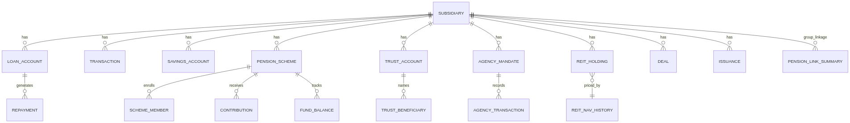
Figure 3 — Entity-Relationship Diagram (rendered).
Tables / Collections
Entity | Subsidiary | Key fields
subsidiary | — | id, name, code
loan_account | Rukisha | id, subsidiary_id, product, outstanding_balance, days_overdue, status
repayment / repayment_schedule | Rukisha | id, loan_account_id, amount, due_date, paid_date
transaction | Rukisha | id, subsidiary_id, wallet_id, type, amount, created_at
wallet | Rukisha | id, subsidiary_id, status, last_transaction_at
savings_account | Rukisha | id, subsidiary_id, account_holder_id, savings_type, balance
pension_scheme | CPF Financial Services | id, subsidiary_id, status
scheme_member | CPF Financial Services | id, pension_scheme_id, member_id
contribution / withdrawal | CPF Financial Services | id, pension_scheme_id, amount, period
fund_balance | CPF Financial Services | id, pension_scheme_id, period, opening_balance, closing_balance
trust_account | CPF Financial Services | id, subsidiary_id, trust_asset_value, status
trust_beneficiary | CPF Financial Services | id, trust_account_id, beneficiary_id
agency_mandate / agency_transaction / fee_ledger | CPF Financial Services | id, subsidiary_id, principal_id, amount, fee_amount
reit_holding / reit_nav_history / reit_distribution | CPF Capital & Advisory | id, subsidiary_id, holder_id, unit_balance, nav_per_unit, period
deal | CPF Capital & Advisory | id, subsidiary_id, deal_type, deal_value, advisory_fee, close_date
issuance | CPF Capital & Advisory | id, subsidiary_id, instrument_type, issuance_value, profit_rate, amount_offered, amount_subscribed
pension_link_summary | Group (aggregate) | id, period, linked_savers_pct, aum_deployed_pct, returns_credited_pct
Relationships
Every fact table has a many-to-one relationship back to subsidiary via subsidiary_id. Within a subsidiary, operational entities (e.g. loan_account → repayment, pension_scheme → contribution) follow standard one-to-many relationships. pension_link_summary is a group-level aggregate table, not a per-customer join — consistent with the Phase 1 "Option 2" decision (ADR-0002, Appendix A).
Migration Strategy
Versioned SQL migrations managed through Supabase; the dummy dataset is loaded by a Python/pandas seed script run after migrations, not hand-entered.

6. External Interfaces
User Interface: horizontal collapsible navigation (subsidiary tabs, Group View, About); individual, responsive KPI tile cards (four per pillar) with per-tile info tooltips; trend/bullet charts; a header alerts panel; a hero toolbar with search, period switch and export; a footer matching the navigation bar in style.
External APIs: Supabase client SDK only, wrapped per the Adapter pattern — no other third-party API is called.
Network Protocols/Communication: REST via Supabase's PostgREST layer and Next.js API routes.

7. Security Considerations
Authentication: none — explicitly out of scope and documented as a stated limitation, not an oversight (Phase 1 Scope Note).
Authorization: none — single-user, demo-style access.
Data Protection: dummy data only; no PII; secrets (Supabase keys) held in environment variables, never hard-coded.
Compliance: not applicable to this prototype; noted for a future real-data phase (Kenya Data Protection Act awareness).
Threat Model: minimal — the main accepted risk is that the prototype has no authentication; mitigated by using only dummy data and not exposing it as a production system.
flowchart TB
subgraph Public["Public Internet - Untrusted"]
B["Browser - No Authentication"]
end
subgraph Trusted["Vercel / Supabase - Trusted Boundary"]
APP["Next.js App"]
DB[("Supabase Postgres - Dummy Data Only")]
end
B -->|"HTTPS, no login required"| APP
APP --> DB
RISK["Accepted Risk: No Auth (documented)"] -.-> B
Mermaid source — threat model.
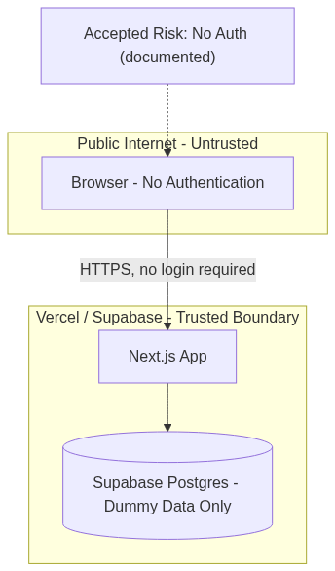
Figure 4 — Threat Model Diagram (rendered).

8. Performance and Scalability
Expected Load: single-user demo; a small dummy dataset (hundreds to low thousands of rows).
Caching Strategy: none required yet; the data-access layer is isolated so a cache could be added later without touching the UI (Open/Closed).
Database Optimization: indexes on subsidiary_id and the relevant date/period column on every fact table.

9. Deployment Architecture
Environments: local development, Vercel preview (per pull request), Vercel production (main branch).
CI/CD Pipeline: GitHub Actions runs install → lint → build on every push/PR; Vercel auto-deploys on merge to main.
Cloud/Hosting: Vercel (application) and Supabase (database).
Containerization/Orchestration: none — unnecessary for a managed serverless deployment at this scale (KISS/YAGNI).

10. Testing Strategy
Unit Testing: the pure core-logic functions (one per KPI) are tested directly, with no database or network required.
Integration Testing: the data-access layer is tested against a Supabase development project.
End-to-End Testing: none automated — structured manual QA against the Phase 1/2 requirements instead, sized for a two-week prototype (see the Execution Plan's Testing phase for the exact edge cases).
Quality Metrics: ESLint clean in CI; the Clean Coding Practices and Core Design Principles quick-reference checklists applied as a self-review pass before each release.

11. Appendices
A. Diagrams
- Figure 1 — System Architecture Diagram — §3.
- Figure 2 — Data Flow / Control Flow Sequence Diagram — §3.
- Figure 3 — Entity-Relationship Diagram — §5.
- Figure 4 — Threat Model Diagram — §7.
- Each diagram appears in its section both as Mermaid source (editable) and as a rendered image (viewable without any additional tooling).
- Live, interactive visual reference: the dashboard mockup artifact built during Planning and refined through Design (see project records for the current link).
B. Architecture Decision Records
ADR-0001: Shared Schema with a Subsidiary Field
Context: the three business lines (lending, pensions, capital markets) could be modelled as three separate schemas, or one shared schema distinguished by a subsidiary field.
Decision: use one shared Postgres schema; every fact table carries a subsidiary_id foreign key to a single Subsidiary dimension table.
Consequences: enables the Group Comparison View's cross-subsidiary aggregation without cross-database joins, and accommodates a fourth subsidiary later without restructuring (Core Design Principles — "Accommodate Change"). Trade-off: slightly less domain isolation than fully separate schemas, mitigated by always indexing and filtering on subsidiary_id.
ADR-0002: Aggregate-Level Group Connection Linking
Context: the Group Comparison View's Connection layer needed to show how the three subsidiaries relate (e.g. Rukisha's pension-linked savers feeding CPF Financial Services' schemes). Three options were considered: (1) a minimal side-by-side view with no real linkage; (2) aggregate-level linking fields seeded alongside the dummy data; (3) full row-level customer/member matching across subsidiaries.
Decision: Option 2 — a small set of aggregate linking fields (linked savers %, AUM deployed %, returns credited %), stored in a dedicated pension_link_summary table, not computed from a live cross-subsidiary join.
Consequences: tells the real inter-subsidiary story the finance manager asked for, without the schema and engineering cost of row-level customer matching across business lines in a two-week prototype (YAGNI). Trade-off: the Group Scorecard's "Total Active Clients" is a simple sum across subsidiaries, not deduplicated — documented as a known limitation in the Phase 2 Analysis document §1.
C. Change History
Version | Date | Author | Changes
1.0 | 2026-10-02 | Vincent Onchieku Collins | Initial Software Design Document, built on the approved Phase 1 Scope Note and Phase 2 Analysis.

